**GUJARAT** **TECHNICAL** **UNIVERSITY**



SARVAJANIK COLLEGE OF ENGINEERING & TECHNOLOGY

(Faculty of Computer Engineering, Computer Department)

A Project Report

On

**OBSCURE LOCK**

Under the course of

B. E. III, Semester – VII

(Computer Engineering)

***Submitted*** ***by:***

|  |  |  |
| --- | --- | --- |
| **Sr.** | **Name** **of** **student** | **Enrolment** **No.** |
| 1 | DARSHIT AKBARI | 160420107002 |
| 2 | KEVAL NAVADIYA | 160420107031 |
| 3 | PARTH ROY | 160420107046 |
| 4 | DHRUVI SHAH | 160420107050 |
| 5 | SHREYA BOHRA | 160420107054 |

------------------------------- Prof. Bhavesh Patel

(Faculty Guide)

-----------------------

Prof. (Dr.) Pariza kmboz

(Head of the Department

**INDEX**

|  |  |  |
| --- | --- | --- |
| Sr. No. | Topic Name | Page No. |
| 1 | Introduction | 4 |
| 2 | Aim and objective | 4 |
| 3 | Brief literature review  Description  Features  Patent search  Assumptions and Dependencies  Constraints  Multiple lock mechanism  Working  Efficient users | 5 |
| 4 | Materials and Methods  Operating environment  Software required  Hardware required | 7 |
| 5 | Prototype Model UML  Use-case model  Activity diagram  Class diagram  Sequence diagram | 8 |
| 6 | Ghant chart | 10 |
| 7 | Methodology of design driven innovation  AEIOU Summary sheet  Empathy canvas  Ideation canvas  PDC | 11 |
| 8 | Outcomes | 14 |
| 9 | Conclusion | 14 |
| 10 | References | 15 |

**INTRODUCTION**

* In today’s world security is one of biggest aspect people look forward to whether it’s their family members protection or their precious valuables protection.
* After having so many elementary solutions to the security problems,(like Intrusion Alarm, Hold-n-panic Alarm, CCTV etc.) there are lot of robbery reports been filed daily.
* To improve the situations we have come up with new idea to protect your valuables.

**AIMS AND OBJECTIVE**

* We aim to create a system which is more safer than the existing systems. That leds the emporium to become a better and safer place that ensures complete safety of their valuables.
* We have come up with solution “OBSCURE LOCK”

**BRIEF LITERATURE REVIEW**

DESCRIPTION

* Today, security is a major area of concern for people with a lot of precious elements, gems, jewels etc. Whether your company is a small local shop or a major international business, you must remain cognizant of the potential security issues facing your organization. To overcome these issues many security methods are designed and developed.
* For a better approach to the issue, the system “OBSCURE LOCK ” is designed and developed for the betterment of the jewellery showroom. This system will provide with virtual lock mechanism that can be used in any locker/safe/block of the showroom which will be operated using a Mobile Application with the concepts of augmented reality. The mobile application will use camera and will augment pattern dots or numeral while facing the objects. You have to draw/write the correct pattern/numeral to unlock the Locker/safe/block which is under the surveillance of the “ OBSCURE LOCK App ”.
* The block will open instinctively once the password/pattern is correctly entered. This functionality is performed using an IOT sensor and analyze weight inside the block/safe.
* Another sort of functionality that is provided by the system is a chain of blocks between the user. The authentication of each user is accomplished using blockchain notion.
* The top level diagram depicts the complete user features that are on their ways for users

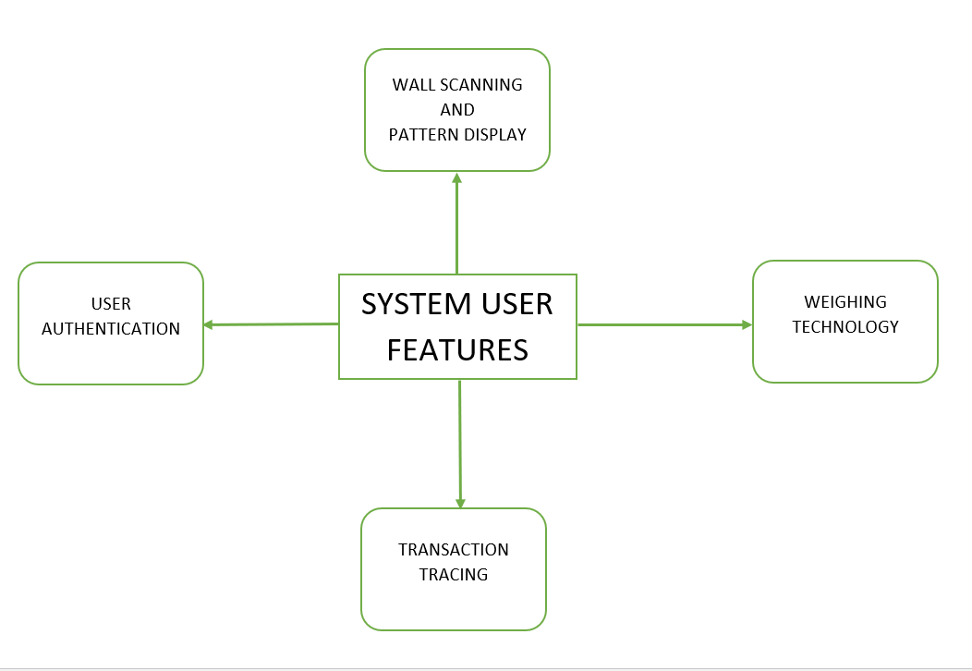

FEATURES

* The fundamental attribute of our system which builds the system:
* Obscure: The system is invisible to the surroundings. There are some particular users been defined by the owners of the emporium to whom this is visible through there gadgets .
* User Authentication: Every individual who is a part of the system is provided with a user substantiation password which is noticeable only when user keep their mobile phones facing the walls.
* Wall Scanning: When a particular individual whose is a responsible handler of the system keeps there mobile facing the walls a scanning takes place to examine the wall is under the surveillance of our system.
* Weighing Technology: Once a user tries to keep something or take out anything from the safe weight of the safe is calculated and recorded each time.

PATENT SEARCH

* Relevant patents in regards of our project:
* PATENT 1 : Augmented reality advanced security authentication methodologies
* PATENT 2 : Intelligent door lock system
* PATENT 3 : Wireless door lock mechanism
* PATENT 4 : Embedded internet of things hub for integration with an appliance and association system and methods

ASSUMPTIONS AND DEPENDENCIES

* The assumption made to execute the core idea are:
* The staff members will have a smart phone
* The showroom/area where the locker is kept is having a Wi-Fi connection.

CONSTRAINTS

* The constraints that are required to efficiently run the system in any showrooms
* Wi- Fi Routers
* Data Analyst

MULTIPLE LOCKING MECHANISM

* Each safe has a separate lock mechanism system where each lock system is given a unique locker id and the system will analyse the locker id accordingly.
* The locker id respective to the locker will be consulted in the database and the pin in regards with that locker will be used to open that locker.
* Each safe is absolutely independent of the other accept the fact that they are assigned a locker id.

WORKING

* Face your mobile to the marker on the locker, the mobile camera will project to the marker and will check which locker id is corresponding to that locker and marker in the database.
* If the pin corresponding to the locker is correct then the locker will open inside the locker.
* Once the lock is open then the servo motor connected to the lock will rotate to 90 degree which will open the door of the locker.
* If you pick out or keep something from/in the locker the weight of the locker will be calculated and store in the database include the persons details who has opened the door.
* Once everything is done and you are about to close the locker with your phone the servo motor will again rotate its direction which will led to close the door of the locker.
* After door is completely closed the lock will again come out and the the door will protect with lock again.

EFICIENT USERS

* Data Analyst: These people are the one who operates the database of the system within the emporium.
* Showroom Executives: They handle the safe directly by their mobile phones which helps them open and close the safe.

**MATERIALS AND METHODS**

OPERATING ENVIRONMENT

|  |  |  |
| --- | --- | --- |
| Particulars | Client System | Server System |
| Operating System | Android  IOS | Platform independent(Web based) |

SOFTWARES REQUIRED

* Front end software’s

|  |  |
| --- | --- |
| **Languages** | **Description** |
| Vuforia | For Augmented Reality |
| Ethereum IDE | Blockchain |
| Flutter | IOS and Android Apps |
| Deep Learning | Wall Scanning |

* Back end software’s

|  |  |
| --- | --- |
| **Software Parts** | **Description** |
| Operating System | Windows/Linux |
| Database | Firebase |

HARDWARE REQUIRED

* Servo Motor
* Weight sensor(HX711)
* Load cell(1 kg)
* LOCK
  + Electric solenoid lock
  + Fire Walt 1mpr relay
* Node MCU(ESP 8266)
* Jumper wires

**UNIFIED MODELLING LANGUAGE**

The **Unified Modeling Language** (**UML**) is a general-purpose, developmental, modeling language in the field of software engineering that is intended to provide a standard way to visualize the design of a system.

**USE-CASE**

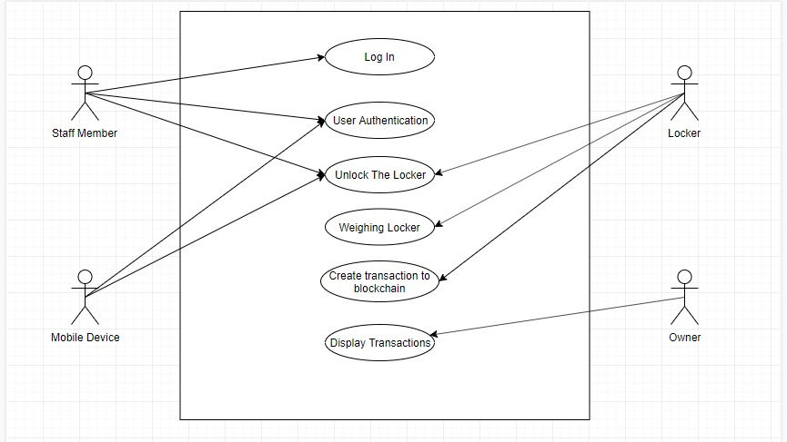

**CLASS DIAGRAM**

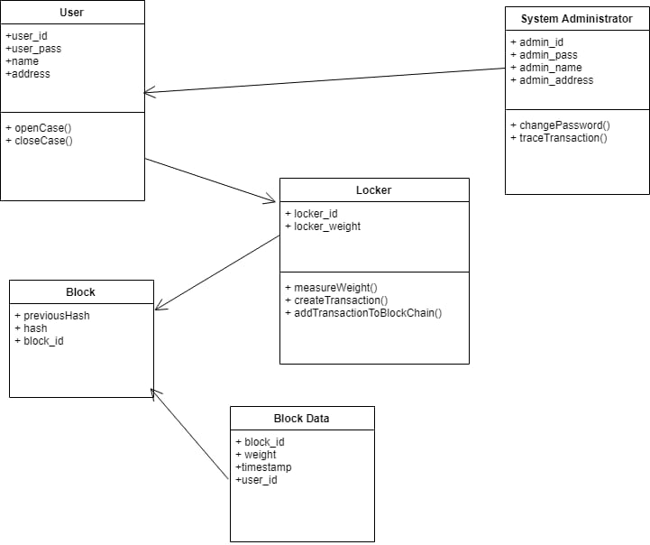

**SEQUENCE DIAGRAM**

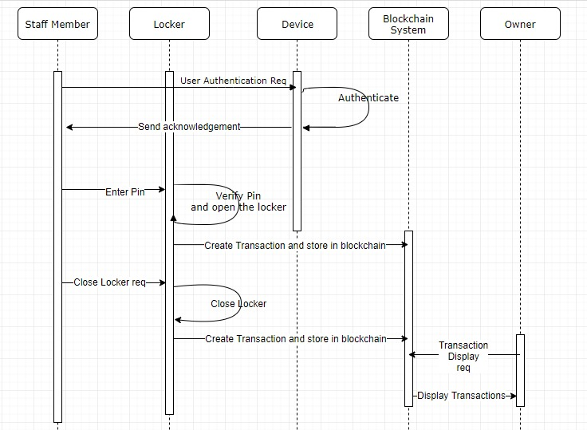

**ACTIVITY DIAGRAM**

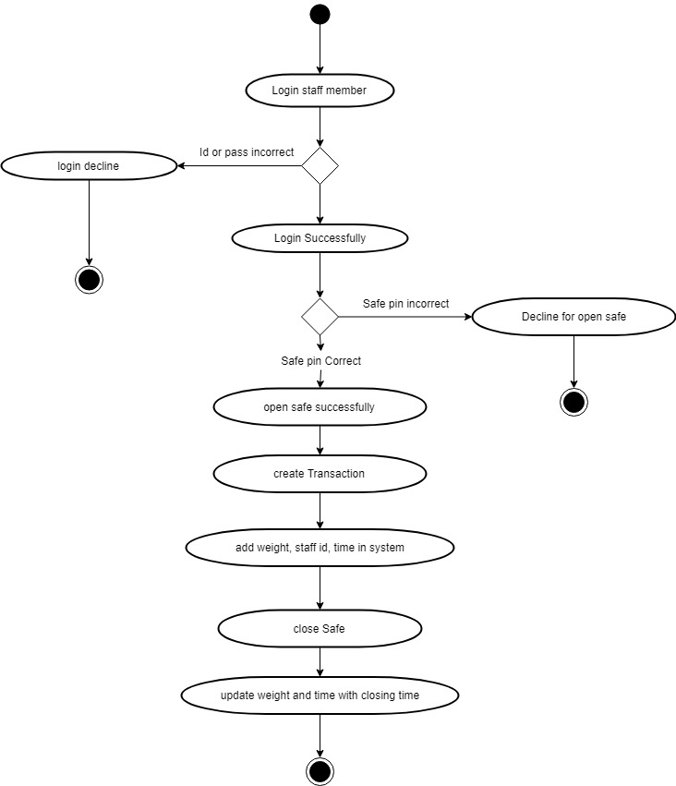

**GANTT CHART**

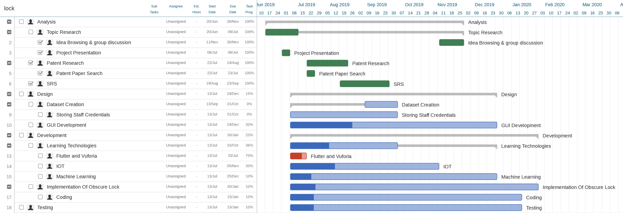

**METHODOLOGY OF DESIGN DRIVEN INNOVATION**

1. AEIOU Summary Sheet

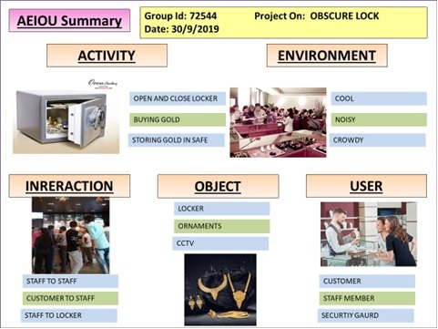

1. EMPATHY CANVAS

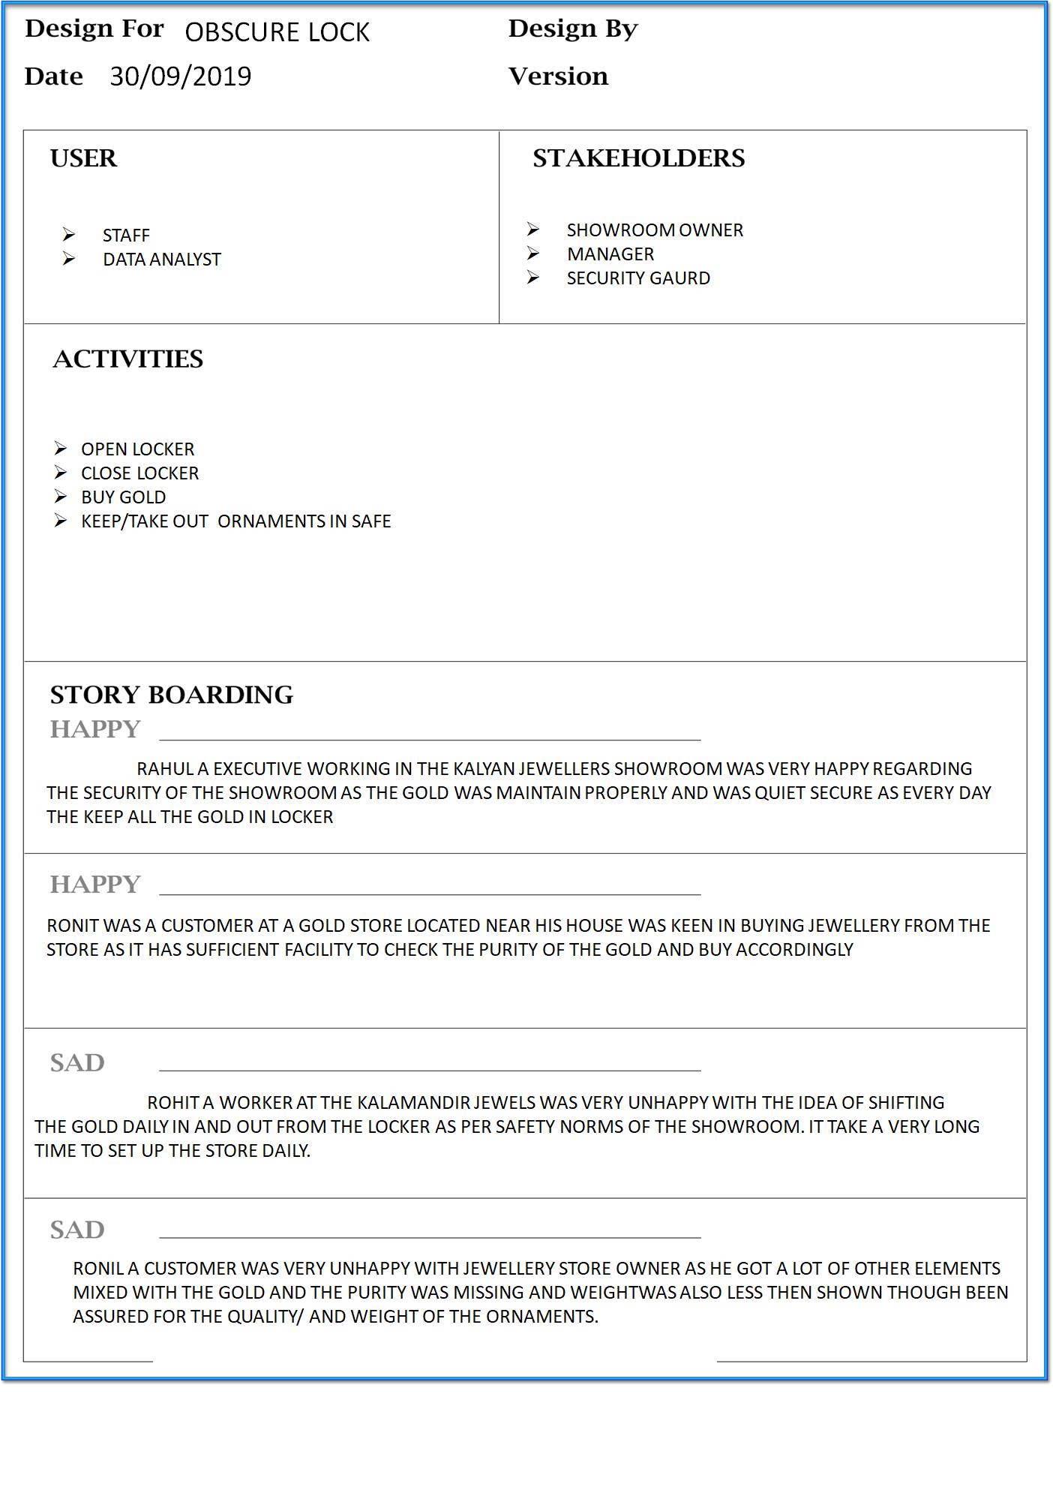

1. IDEATION CANVAS

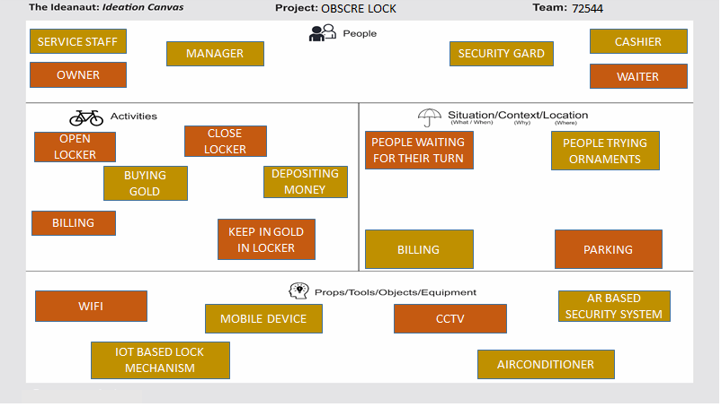

1. PDC CANVAS

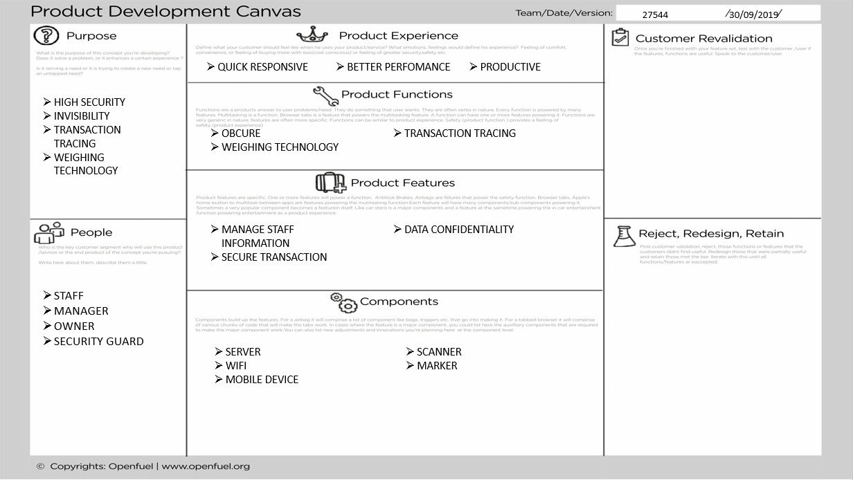

**OUTCOMES**

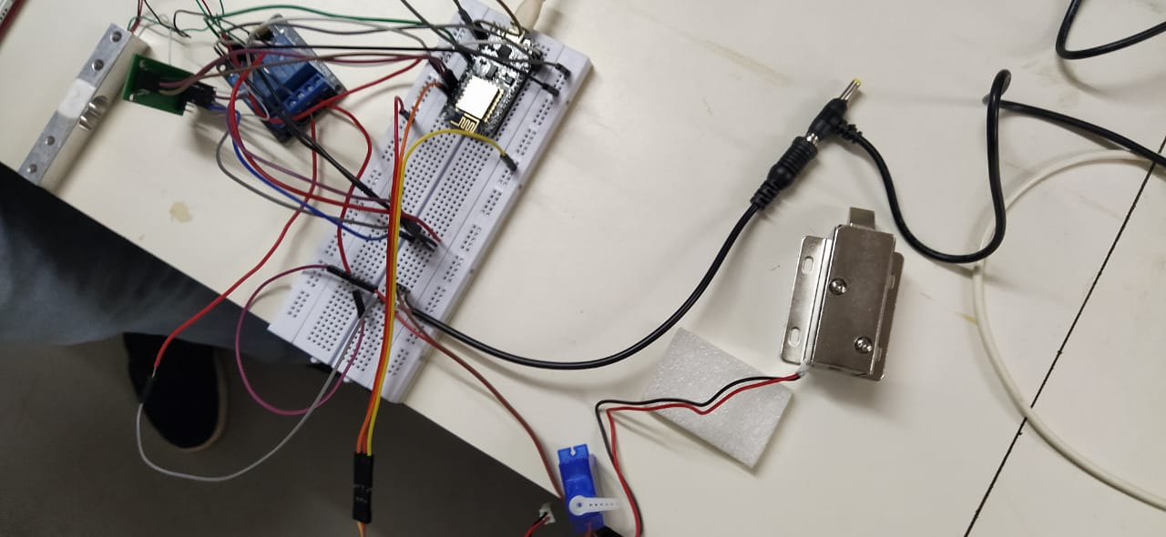

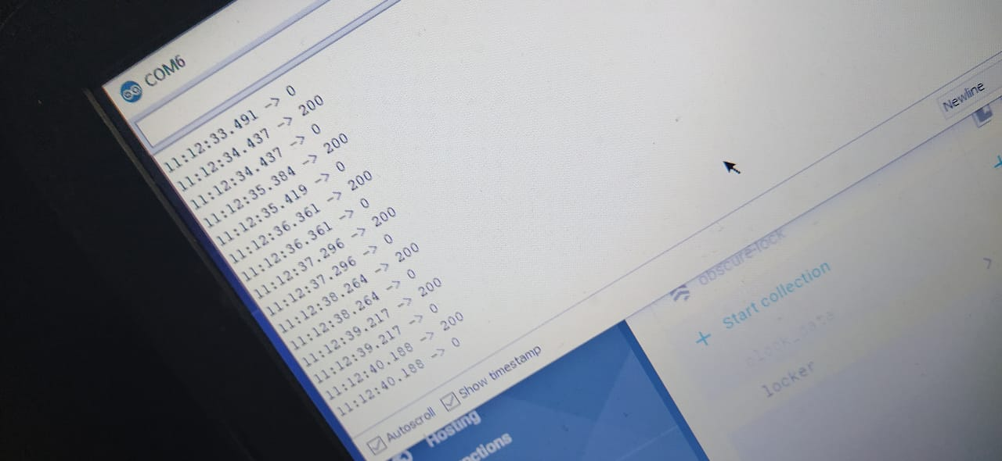

**CONCLUSION**

The main objective behind this innovations was to take care of the your valuables and provide your with even safer environment.

In today’s world, there is nobody trustworthy so keep your self away form any awful incident we have brought a much safer and healthier environment for your valuables this will help you keep an eye on the staff members of your emporium keeping a track of their activities regarding the safes and the gold they have taken out.

**REFERENCES**

* file:///C:/Users/SHREYA/Downloads/US9353551.pdf
* <https://instagantt.com/>
* <https://www.hackster.io/projects/tags/internet+of+things>
* <https://www.connectbit.com/blockchain-applications/>
* <https://www.youtube.com/watch?v=W48_2ebuvv8>